Rangani Rampamba

Rosebank
PROG6212

1.Section 1. Entity Relationship Diagram ERD
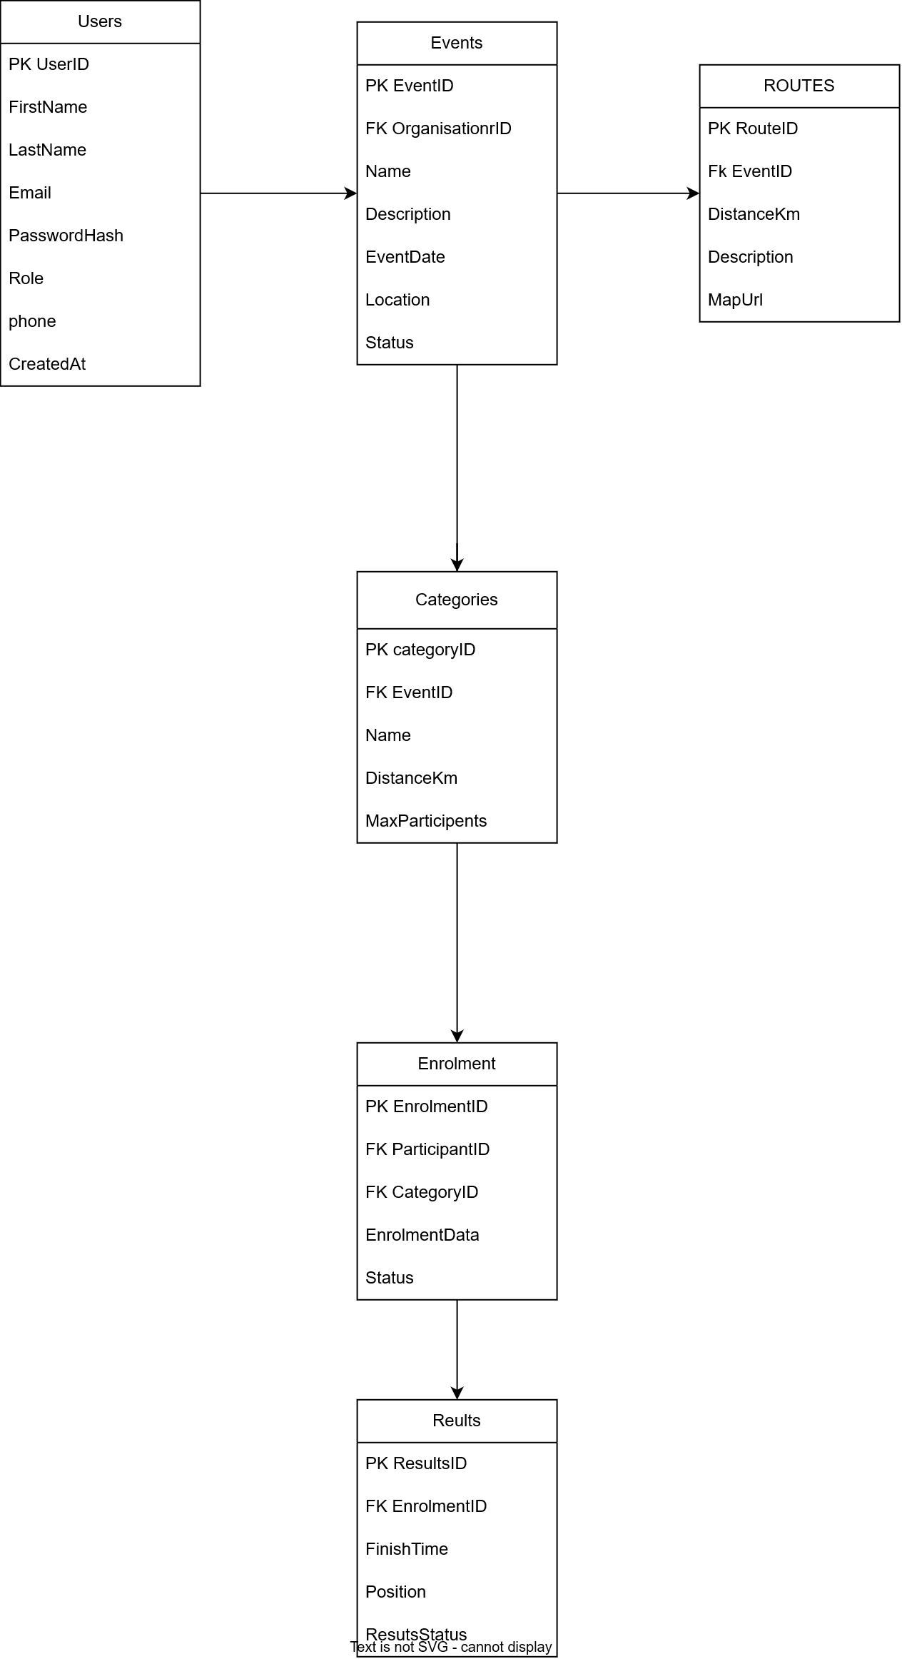

Relationship | Cardinality | Explanation
User → Event | 1:M | One Organiser can create many events
Event → Category | 1:M | One event can have multiple categories
Event → Route | 1:M | An event can contain route information
Participant → Enrolment | 1:M | One participant can enter multiple events
Category → Enrolment | 1:M | One category can have many enrolments
Enrolment → Result | 1:0..1 | An enrolment can have zero or one result

2 SECTION B-API Endpoint Plan

Authentication

Method | Route | Description | Role | Request Body | Expected Response
POST | /api/auth/register | Creates a new participant account | None | FirstName, LastName, Email, Password | 201 Created
POST | /api/auth/login | Authenticates a registered user | None | Email, Password | 200 OK + token
POST | /api/auth/register-organiser | Creates an organiser account | None | FirstName, LastName, Email, Password | 201 Created

User Profile

Method | Route | Description | Role | Request Body | Expected Response
GET | /api/users/me | Returns logged-in user's profile | Any | None | 200 OK
PUT | /api/users/me | Updates the logged-in user's profile | Any | Profile fields | 200 OK
GET | /api/users/{id} | Retrieves a user profile | Organiser | None | 200 OK / 404

Events

Method | Route | Description | Role | Request Body | Expected Response
GET | /api/events | Displays available events | Public | None | 200 OK
GET | /api/events/{id} | Displays one event | Public | None | 200 OK / 404
POST | /api/events | Creates an event | Organiser | Event details | 201 Created
PUT | /api/events/{id} | Updates an event | Organiser | Event details | 200 OK / 404
DELETE | /api/events/{id} | Deletes an event | Organiser | None | 204 No Content
GET | /api/events/{id}/routes | Gets route information | Public | None | 200 OK

Categories

Method | Route | Description | Role | Request Body | Expected Response
GET | /api/events/{eventId}/categories | Lists event categories | Public | None | 200 OK
POST | /api/events/{eventId}/categories | Creates an event category | Organiser | Name, DistanceKm, MaxParticipants | 201 Created
PUT | /api/categories/{id} | Updates a category | Organiser | Category details | 200 OK
DELETE | /api/categories/{id} | Deletes a category | Organiser | None | 204 No Content

Enrolments

Method | Route | Description | Role | Request Body | Expected Response
POST | /api/enrolments | Enters a participant into a category | Participant | CategoryID | 201 Created
GET | /api/enrolments/me | Shows participant's own enrolments | Participant | None | 200 OK
GET | /api/events/{eventId}/enrolments | Shows enrolments for an event | Organiser | None | 200 OK
DELETE | /api/enrolments/{id} | Cancels an enrolment | Participant | None | 204 No Content

Results

Method | Route | Description | Role | Request Body | Expected Response
POST | /api/enrolments/{id}/result | Records a participant result | Organiser | FinishTime, Position, Status | 201 Created
PUT | /api/results/{id} | Updates a result | Organiser | Result details | 200 OK
GET | /api/results/me | Gets participant's results | Participant | None | 200 OK
GET | /api/events/{eventId}/results | Gets all event results | Organiser | None | 200 OK
GET | /api/results/{id} | Gets a specific result | Any | None | 200 OK / 404

3 section 3 SCL database development

